# INTERPRET A DATA VISUALIZATION REPORT

# INSIGHT – 1:

Data Presentation is a top skill only in the United Kingdom because United Kingdom is the only country that has a global average rank for the Data Presentation skill for the year 2016. On the dashboard I clicked on the Data Presentation skill then global average rank for all the countries were highlighted.

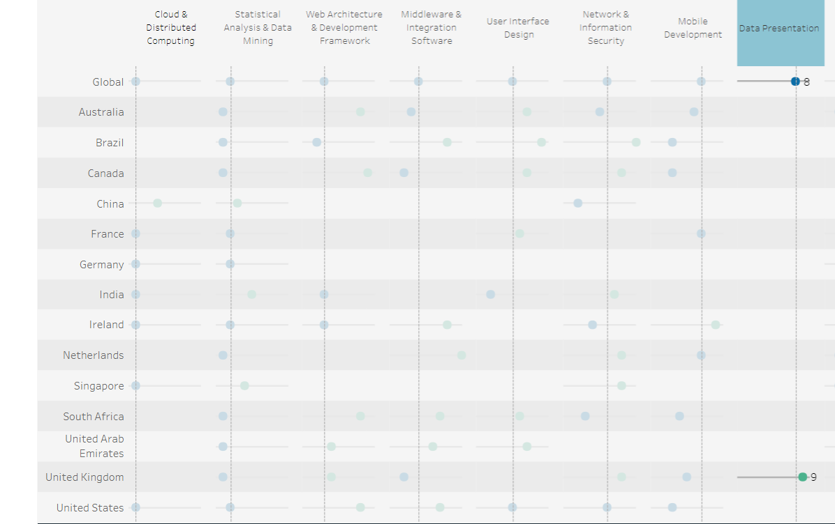

# INSIGHT – 2:

Statistical analysis and data mining is the skill that employers from all the countries need most. This is the only skill that has been listed as a top skill and given global average rank from all the countries. I clicked on the statistical analysis and data mining skill on the dashboard then the global average rank from all the countries were highlighted for this skill.

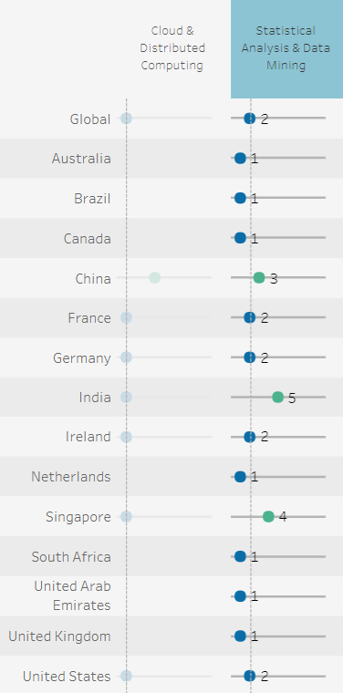

# INSIGHT – 3:

Candidates looking for jobs in Germany have few options of skills to acquire to be in demand because Germany has only three skills as the top skills from the list of skills presented in the dashboard. I clicked on the country name Germany then the three skills which were given the global average ranking for the country were highlighted.

